Name: ……………………………………………………………………………………………
Date of birth: / /

Allergies…………………………………………………………………………………………
……………………………………………………………………………………………………….
……………………………………………………………………………………………………….
☐EpiPen

Medical Conditions: ………………………………………………………………………..
…………………………………………………………………………………………………………
………………………………………………………………………………………………………….
Emergency Contact Phone Numbers:
NAME: ………………………………………………………………………………………………
PHONE: …………………………………………………………………………………………….

NAME: ………………………………………………………………………………………………
PHONE: …………………………………………………………………………………………….

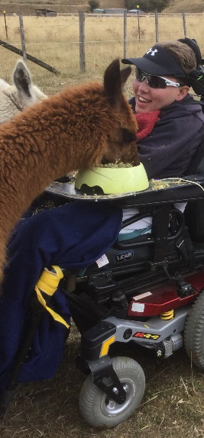
Let us know your preferences: (Please ensure you have read the information provided below to see which booking is right for you)
☐INDIVIDUAL
☐GROUP of two ☐GROUP of three
☐FARM TOUR
☐Additional observational participant

